Project Design Phase-I Solution Architecture

|  |  |
| --- | --- |
| **Team ID** | **BF65628C5F4C176991E4180F64CA6B6F** |
| **Project Name** | **How to create a brand name ,brand mail ,logo in Canva** |

# Solution Architecture:

Before finalizing everything, seek feedback from colleagues or potential clients to make sure your choices resonate with your target audience. Check for trademark availability to make sure your brand name and logo don't infringe on existing trademarks.

Choose a color scheme that reflects your brand's identity. Ensure it's consistent with your industry and the image you want to convey. Brainstorm words and phrases related to solution architecture. Think about your unique selling points and values. Set up email hosting through a provider like Google Workspace (formerly G Suite) or Microsoft 365.

**SOLUTION ARCHITECTURE**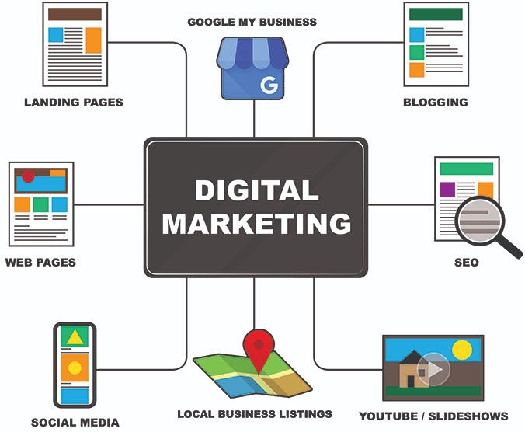

# Flow of a Project:

The data flow of my project is discussed with step by step process as below.

# 1. Define Your Brand Identity:

Start by clearly defining your brand's values, mission, and vision. This will help you create a brand name and design elements that align with your brand's essence.

# 2. Create a Brand Name:

Brainstorm ideas for your brand name. Consider the following:

* Is the name unique and memorable?
* Is it relevant to your products or services?
* Is it easy to spell and pronounce?
* Is the domain name (for a website) available?

# 3. Set Up a Brand Email:

* Purchase a domain name that matches your brand name or is closely related to it. You can use domain registrars like GoDaddy, Namecheap, or Google Domains.
* Sign up for email hosting or use a service like Google Workspace (formerly G Suite) to create a professional email address (e.g., info@yourbrandname.com).

# 4. Create a Logo in Canva:

* Canva is a user-friendly online graphic design tool that can help you design a logo.
* Sign up or log in to Canva (they offer a free plan with limited features and a paid Pro plan with more options).
* Follow these steps to create a logo:
* Choose the "Create a design" option and select "Custom dimensions" to set the size for your logo.
* Use Canva's templates or create your design from scratch.
* Add text, shapes, icons, and images to design your logo.
* Experiment with color schemes and typography to match your brand's identity.

# 6. Legal Considerations:

Check for trademark conflicts to avoid potential legal issues with your brand name or logo.

# 7. Test and Get Feedback:

Share your brand name, email, and logo with a few trusted individuals to gather feedback. Make any necessary adjustments based on their input.

# 8. Launch and Promote:

* Once everything is in place, launch your brand with your new name, email, and logo.
* Promote your brand through various channels, including your website, social media, and marketing materials.
* Remember that branding is an ongoing process, and as your business evolves, you may need to refine and update your brand identity. Canva is a great tool for creating initial design assets, but for more complex design projects, you may want to consider working with a professional graphic designer.

Regenerate